- I really like the list view you created for services page. I think that the size of listing should just be a little smaller so it fits on screen better but keep it close to original bc its cool.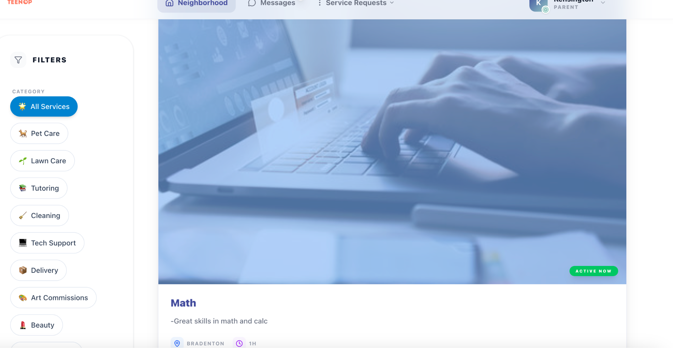
- I don't know why I hadn't thought about this but can we make it so the search bar is two part and searches by service type and location? I know right now its just one area but people technically could be located in different areas. Let me know your thoughts on this.

New Searchbar
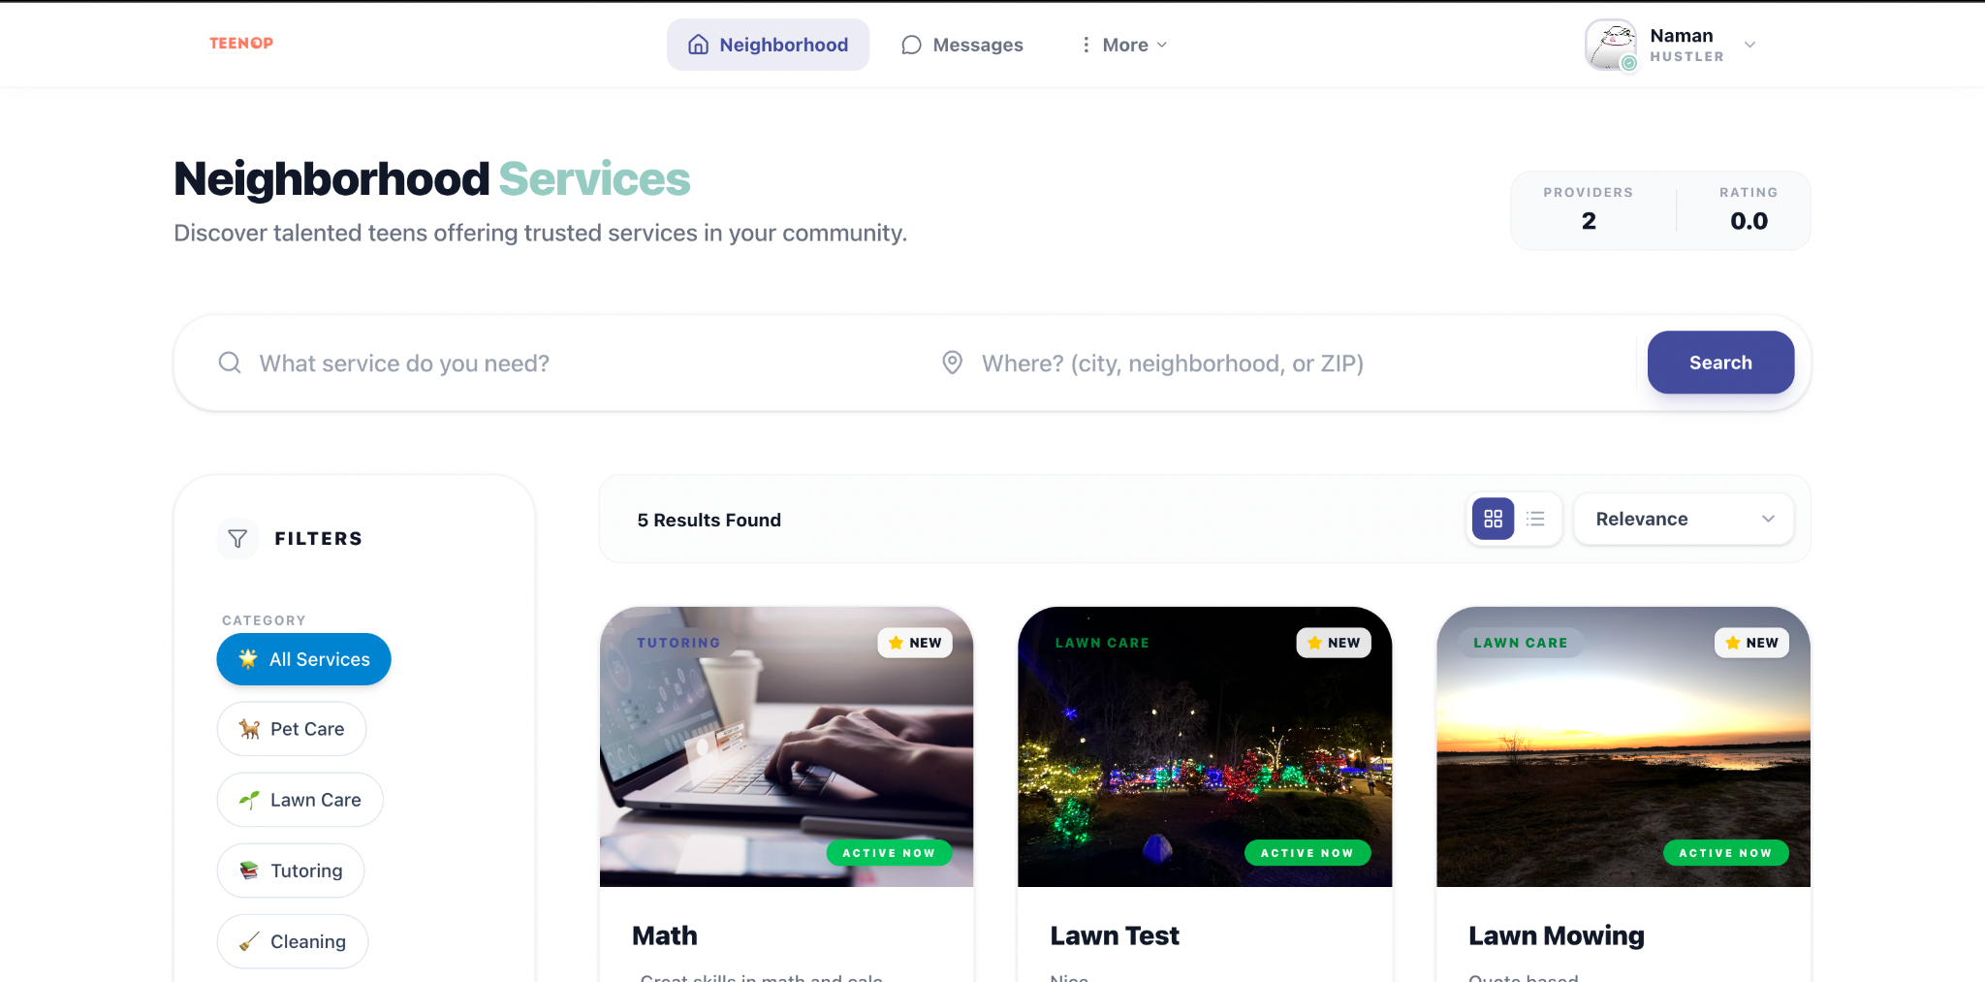

- Small thing but when I hit the mark messages as read it still keeps the alert bubble up.
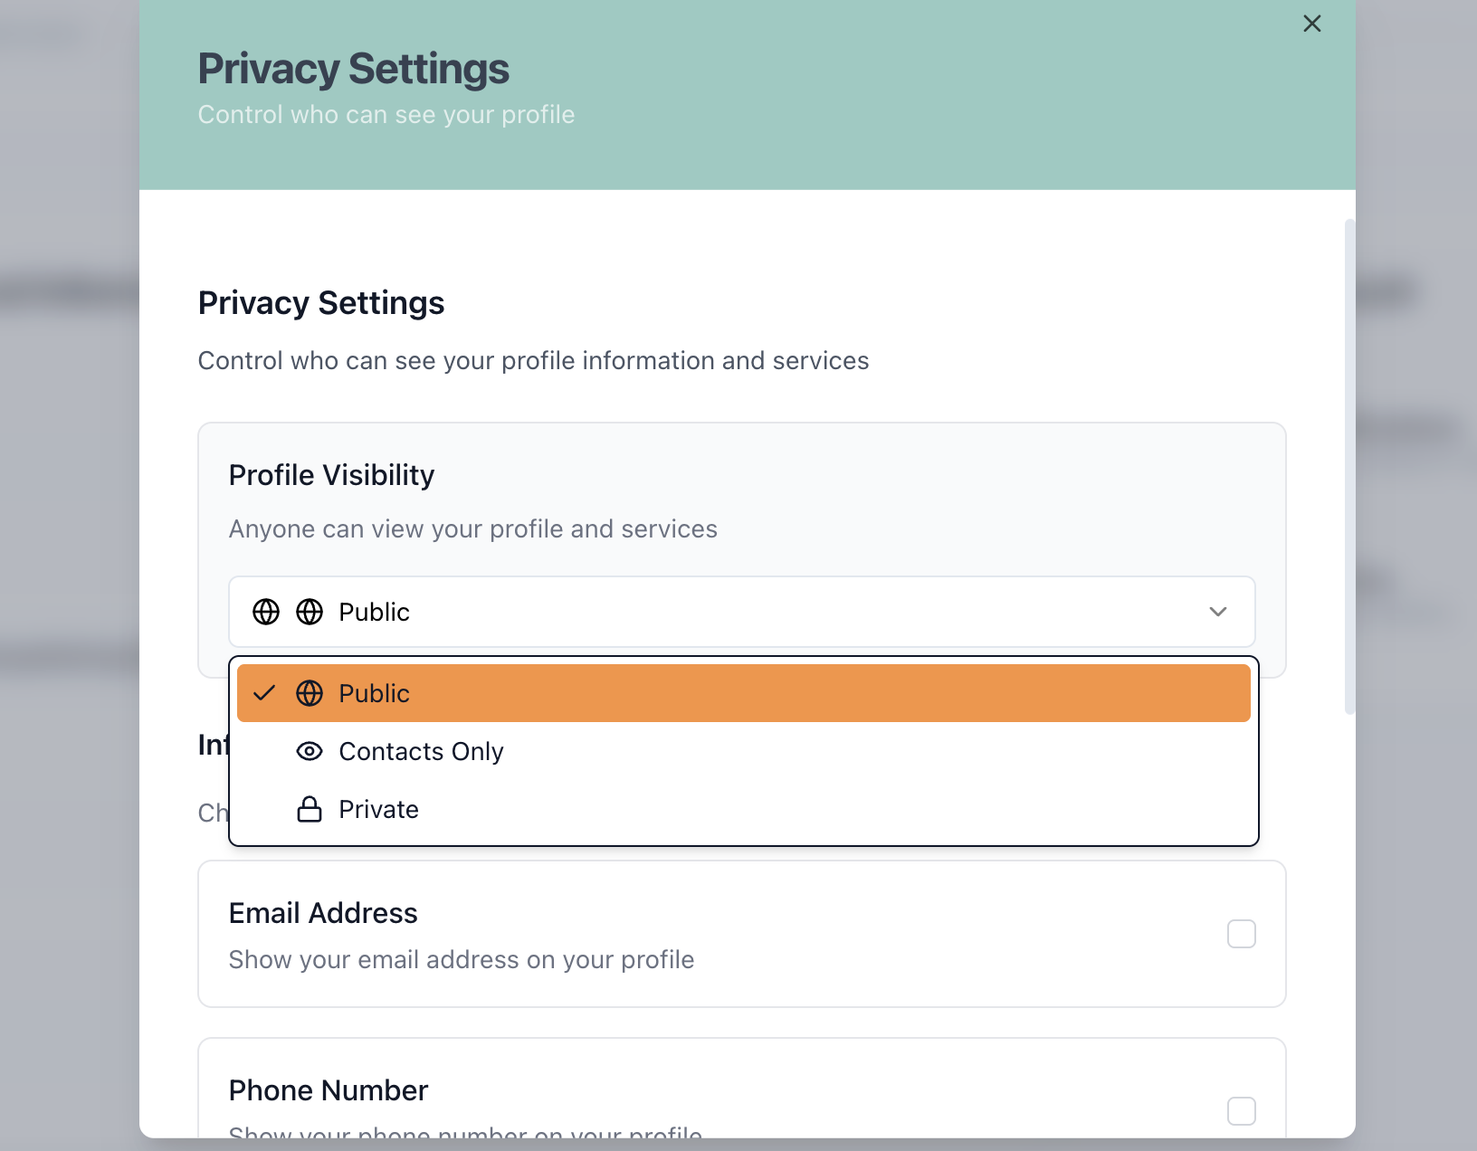
- I think that profile visibility settings should only be on the teens end. I think all parent profiles should be visible.

- For the teens privacy settings you can take away every box but Profile Visibility. There shouldn't be options for any personal info to be shared like phone and email and I also don't think they should have the ability to remove ratings/reviews.
  - I think we should clear up what the difference between Private and Public Profile Visibility is. I think it should be called Storefront Visibility. Make it “Private (only visible to members of your school community)” and “Public (visible to all users on TeenOp).” I dont think the “My Contacts” needs to be there bc im not sure who that would be.
- We talked about this over text but I don't think it makes sense to display services and booking at the top of a parent profile. Instead maybe it could be # of services booked with TeenOp.
- The only things that should be listed on a parent profile are their name, city state, and bio - no phone number on profile. This should be the same on the Teens profile too.
- Can we take away naming the teen as a Hustler. I liked it before but not sure it makes sense the more I look at it. For right now i think stick to Teen.
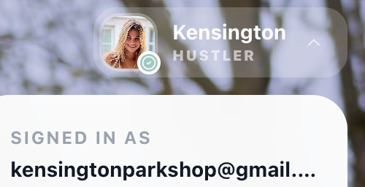
- Can we also change all the places where it say My Teen Hustle to Service Dashboard - I think that will be more clear. Under where it will say Service Dashboard can you change: “Manage your micro-business and earnings” to “Manage your services, bookings, and earnings”
- LOVE all the design changes to the teen hustle page tho everything looks super clean and really well designed so thank u sooo much
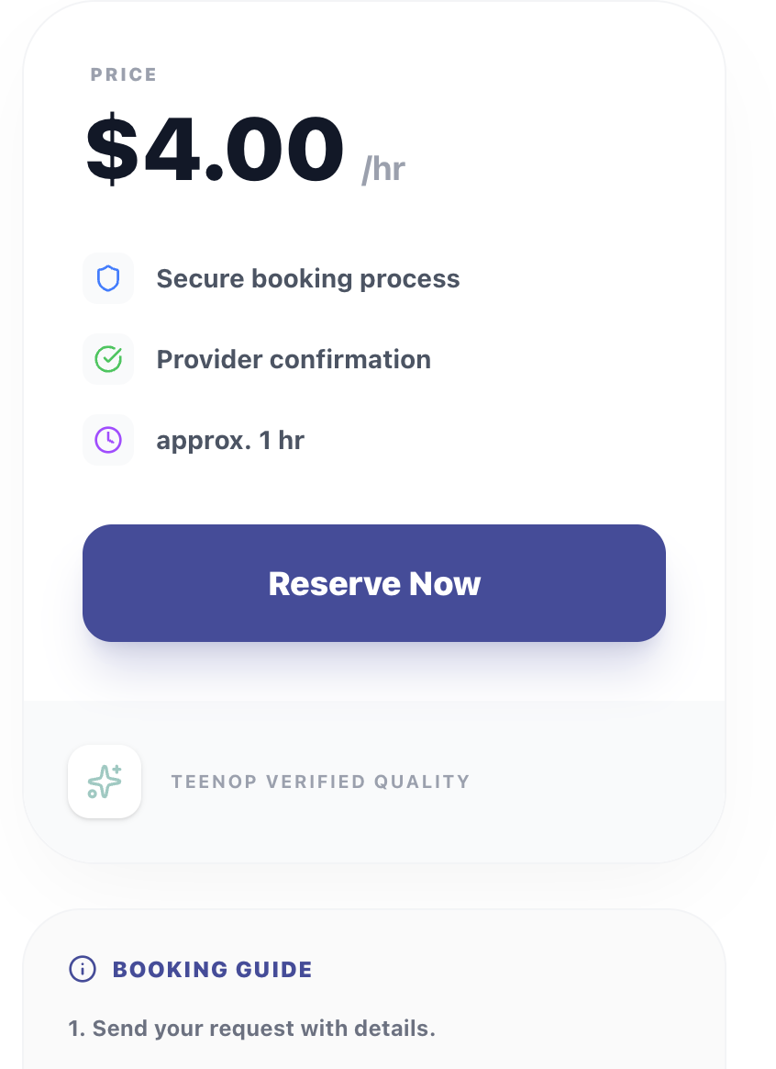
- I think for right now we should hide the line that say TeenOp Verified Quality - just for legal reasons I feel like the law team is going to tell me thats a bad guarantee to publish rn.

- I also really like the design changes when a teen is uploading a new service - I wanted to see if there was any way to add one more text box under Description that said Experience in the text box can say: (Share your experience or skills related to this service). Also I feel like this box may be too big on the site it almost appears cut off, wonder if you could resize to fit on screen better.

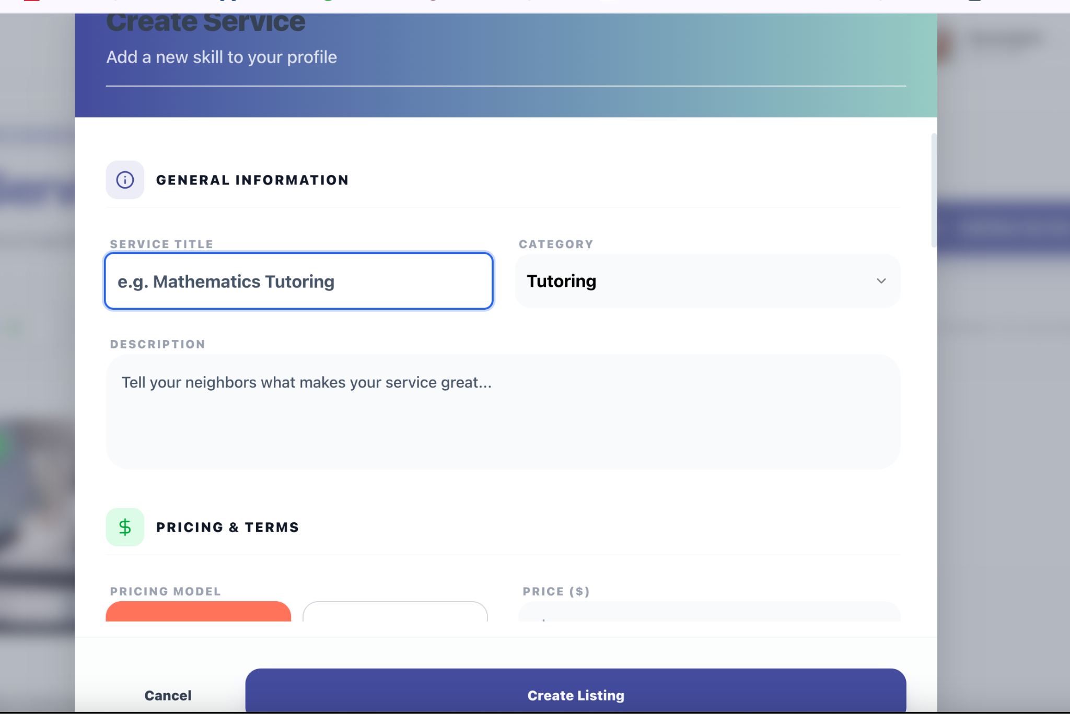
- Under the My Service can you change the “Build your local rep and manage professional offerings” to “Create, manage, or pause your services.”
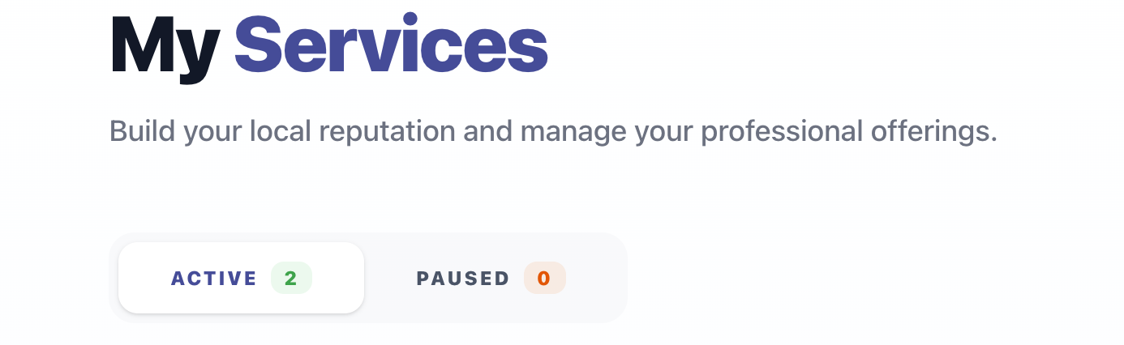

- I kind of think it should be called My Earnings because all the other page names start with My.
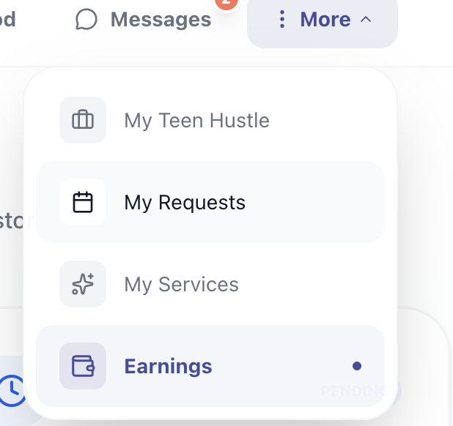

- On the My Earnings page can we change the heading that says “Payout Account” to “Transfer Money to Bank Account” underneath can it say: Earnings from services will be held in Stripe until you manually transfer funds to your bank account. For a step-by-step on how to do this view payout quick guide.

- I think Service Dashboard should be at the top next to Messages and then More. We have talked about putting the alert bubble at the top when a service request comes in like how we have with Messages. Can we still do this? If we take the Service Dashboard out of the menu then it will be easy to see the alert bubble. I was also thinking that an alert bubble should pop up when earnings come in. Not sure if that is possible too.

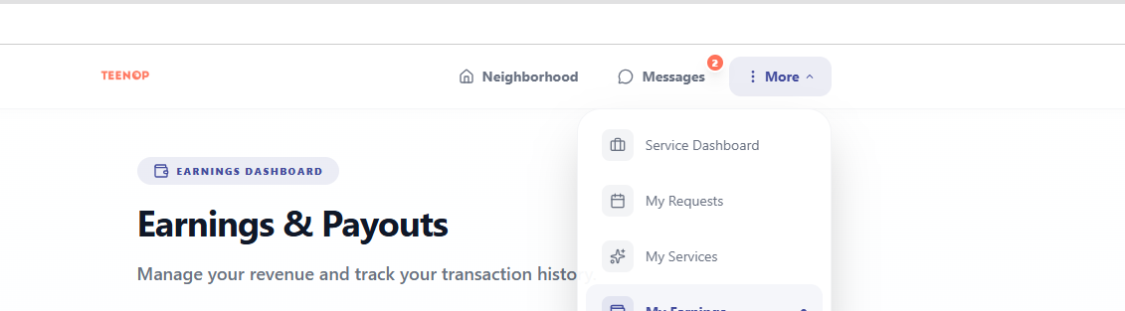
- We talked about there being reminders 3 days, 24 hrs, and then 3 days beforehand. I think we only need to do 24hr then 3 hrs. When I simulate fake services I am not seeing any of these notifications so I’m not sure if we never did them or if you have this feature hidden.
  - In case you don’t have the email templates here they are:
24 Hour Reminder for Teen
Subject: REMINDER: Scheduled Service Tomorrow!
Hello,
This is a reminder that you have an upcoming service scheduled for tomorrow!
Service: [Service Name]
Customer: [Customer Name]
Time: [Date and Time]
Location: [Address or Area]
Take a moment to review the details and prepare.
[Button linking to booking]
We hope everything goes great!
Best,
The TeenOp Team

24 Hour Reminder for Buyer
Subject: Reminder: Scheduled Service Tomorrow
Hello,
You have an upcoming service with TeenOp scheduled for tomorrow!
Service: [Service Name]
Time: [Date and Time]
Teen Provider: [Teen Name]
If you would like to review the details or send a message to your provider, you can do so below.
[Button to View Booking]
Thank you for supporting local teen entrepreneurs on TeenOp!
Best,
The TeenOp Team

3 Hour Reminder for Teen
Subject: Your service starts in 3 hours!
Hi,
Your service is coming up soon!
Service: [Service Name]
Time: [Time]
Customer: [Customer Name]
Please make sure you arrive on time or message your customer on TeenOp if anything changes.
[Button link to booking]
Good luck!
Best,
The TeenOp Team
3 Hour Reminder for Buyer
Subject: Your service starts in 3 hours
Hello,
Your scheduled TeenOp service will begin soon!
Service: [Service Name]
Time: [Time]
Teen Helper: [Teen Name]
You can review your booking or send a message to your teen provider through TeenOp.
[Button to View Booking]
Thank you for using TeenOp. We hope you enjoy your service!
Best,
The TeenOp Team

- I know we had talked about having all the emails to have the same format. I think the only email right now that doesn't have it is this email: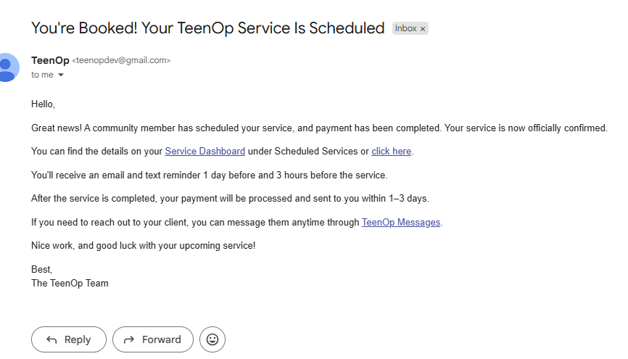
- It would be great if it could match the format of this email that you created:
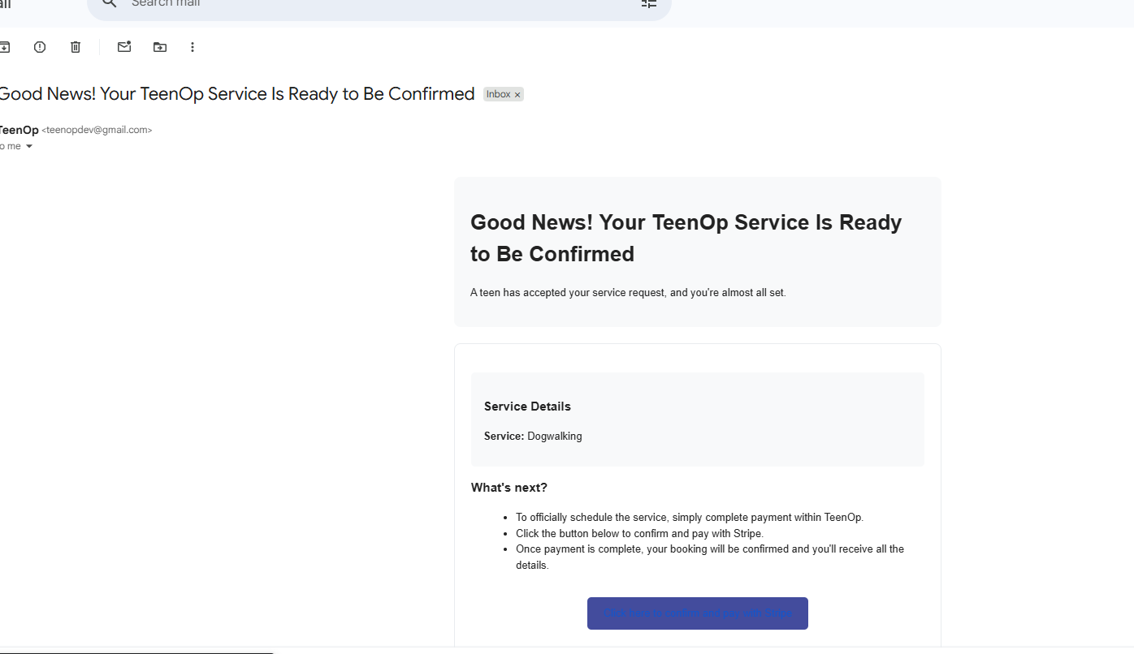
- I also think that something might be weird with the text for this button because the text blends into the blue button.

Aesthetic Changes to Homepage
- Can you make the logo even bigger and put the tagline in bold and black something like what I have below. I think the two buttons could even be bigger as well. This is an idea of what it could look like see if you could make it close to this:
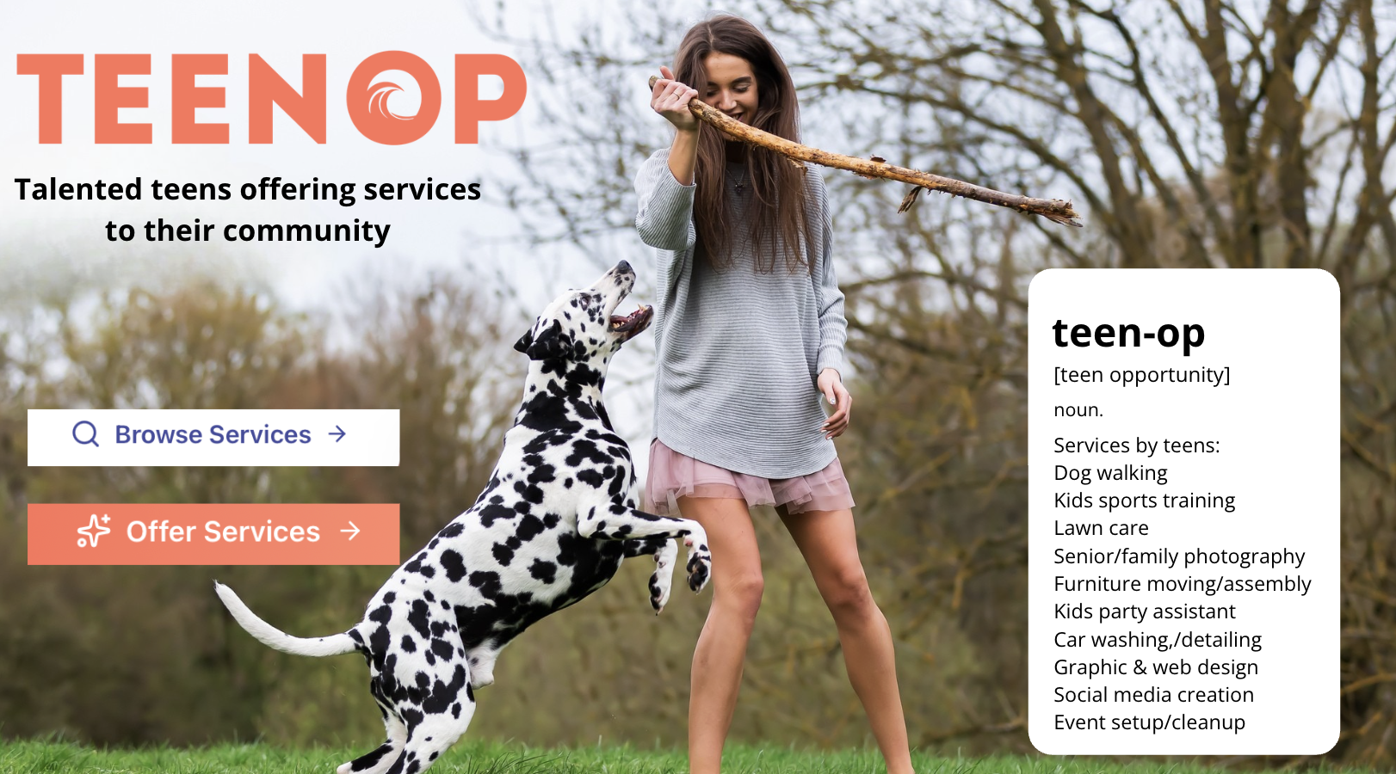

- I edited the original image to make more room for tag line so here is edited version if you want it, not perfect but I think it works:
- 

- Lets change the wording in the definition box to:

[teen opportunity] - don't need to do the pronunciation
noun.

Services by teens:

Dog walking
Kids sports training
Lawn care
Senior/family photography
Furniture moving/assembly
Kids party assistant
Car washing/detailing
Graphic & web design
Social media creation
Event setup/cleanup

- I think we should put a photo in the background of the Join TeenOp page. Here are a few options. Based on quality of picture and how it lays on site I’ll let you pick but here is my thinking in order of which I like best:
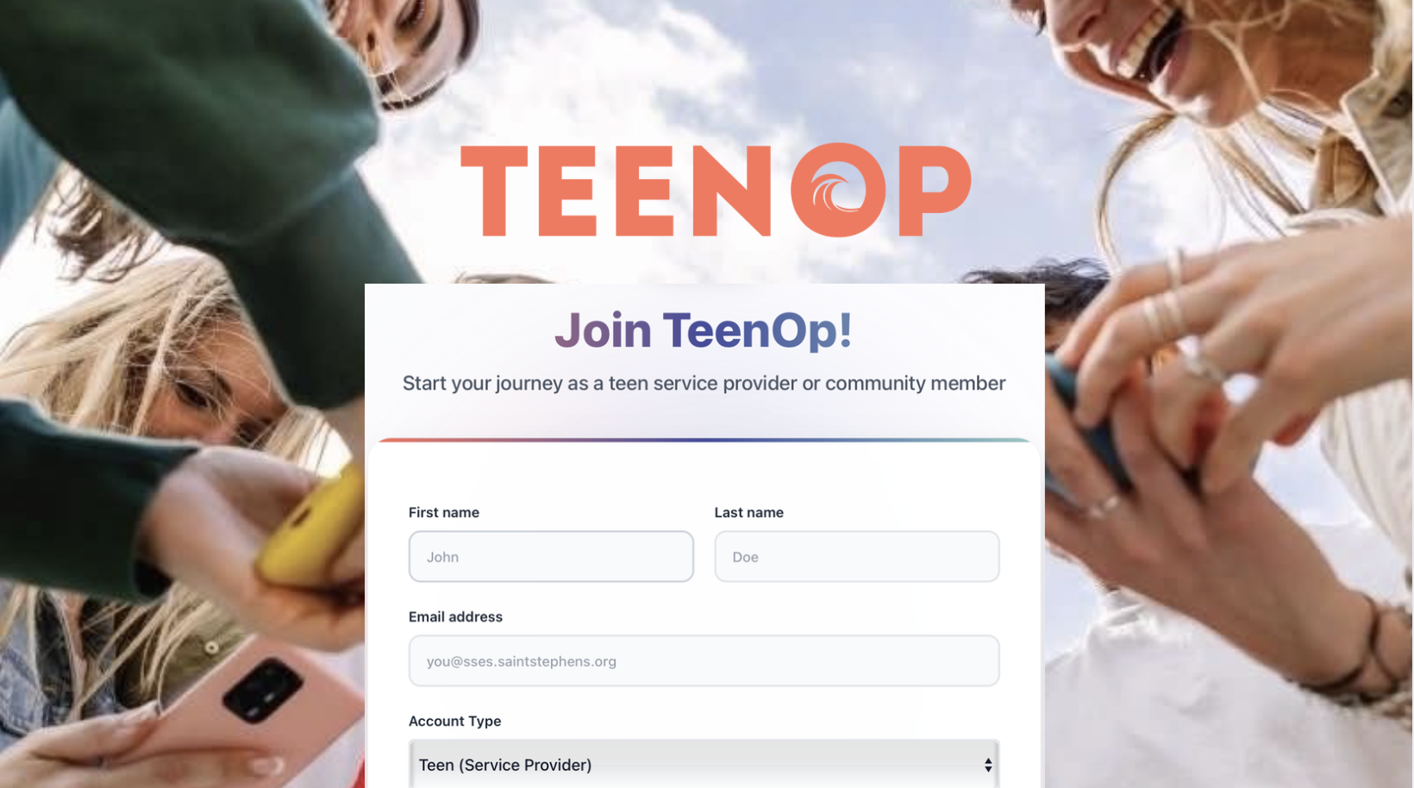

Here is blank image:



If quality or shape doesn’t work try these instead:



Change image background for welcome back to TeenOp to this and make the logo big like this: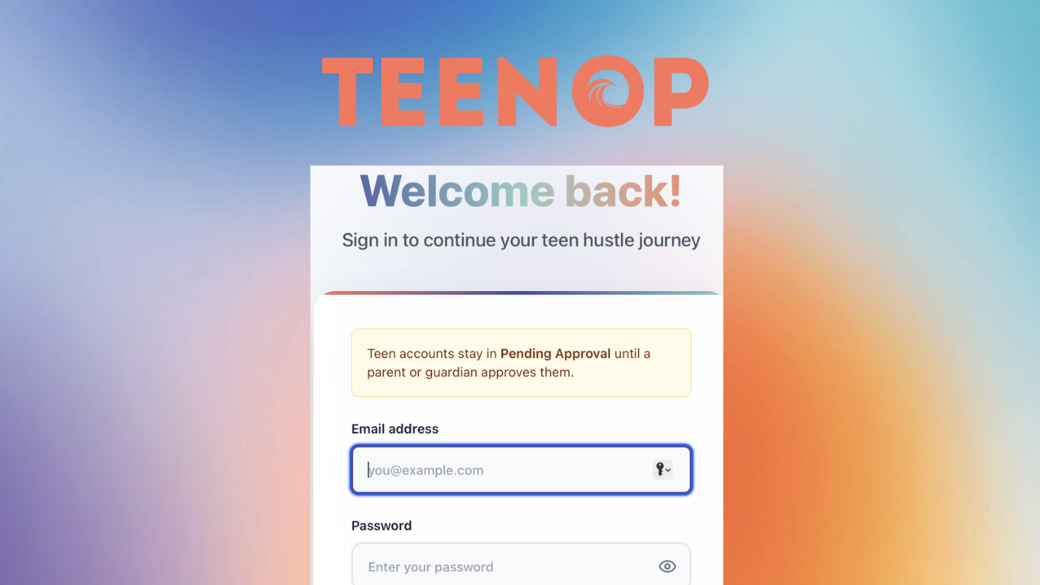

Blank image:


- Even when it signing in as a community member it will come up with the line under Welcome Back saying “Sign in to continue your teen hustle journey” - I think take out this line completely and replace it with “Sign in to your TeenOp Account”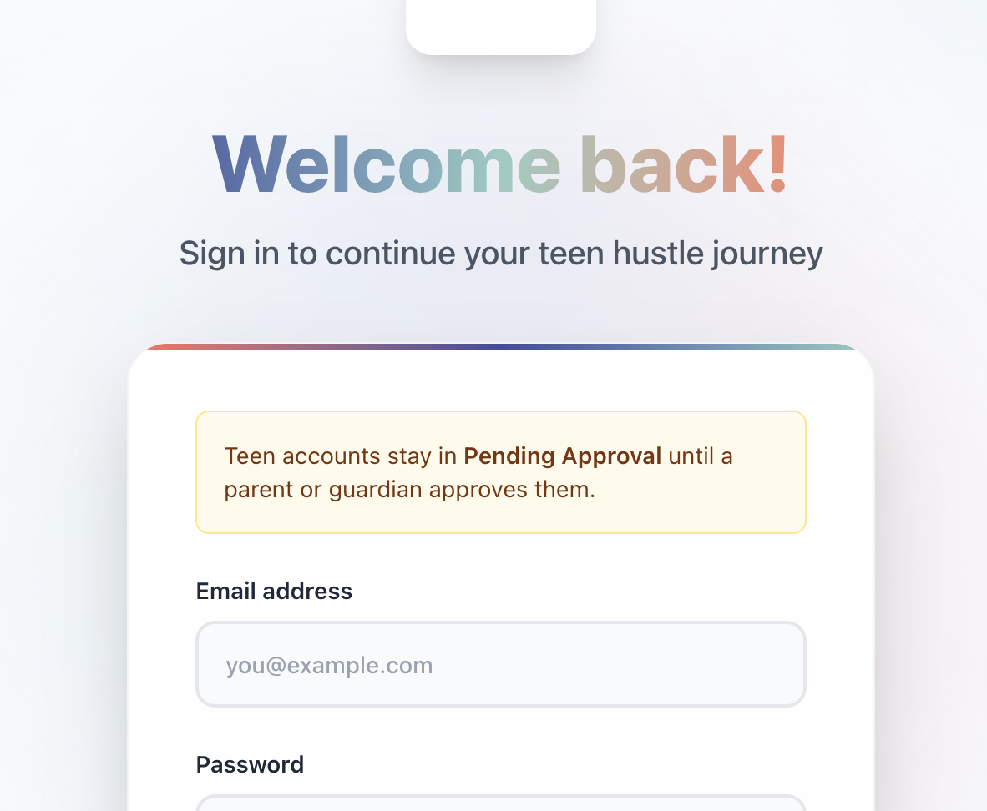

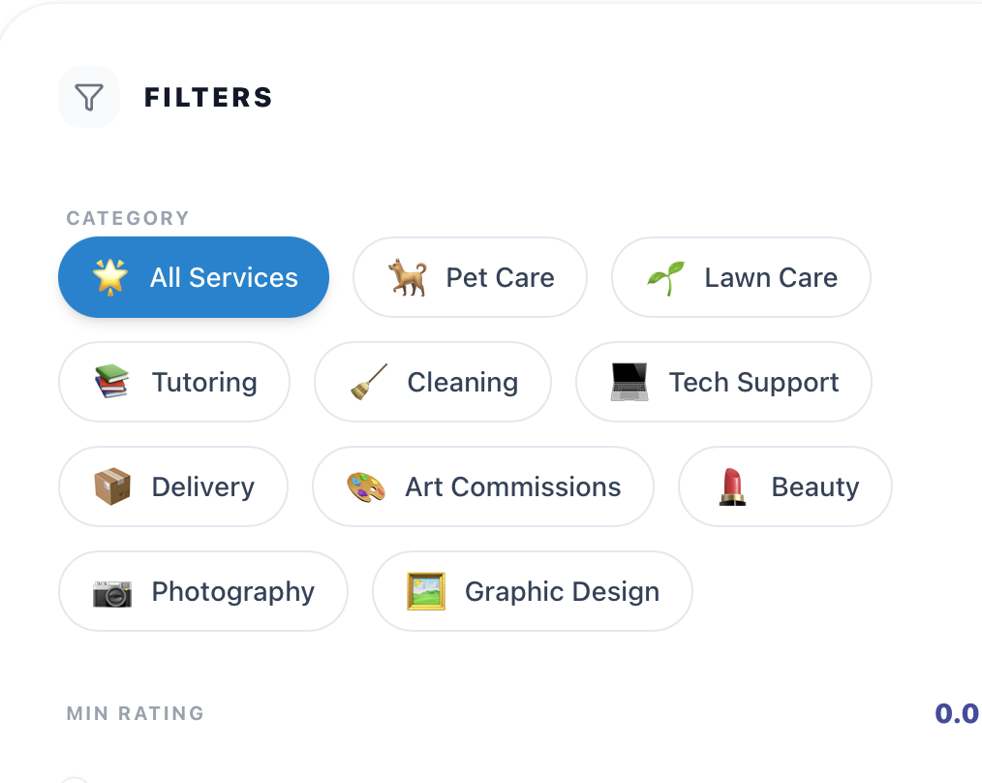
- For the Service Filters: Can you take away Delivery. And add Sports Coaching.

- I think we need something to break up the white space at this part of home page I have a few ideas but I was thinking something like this. I’m not sure how this works on your end but ill attach a link to the Canva elements I used in case that helps???
- https://www.canva.com/design/DAHD73dvy9Y/ZYKJCPALHLJl5mLkgakwOA/edit?utm_content=DAHD73dvy9Y&utm_campaign=designshare&utm_medium=link2&utm_source=sharebutton
- Not sure whats possible but just a thought

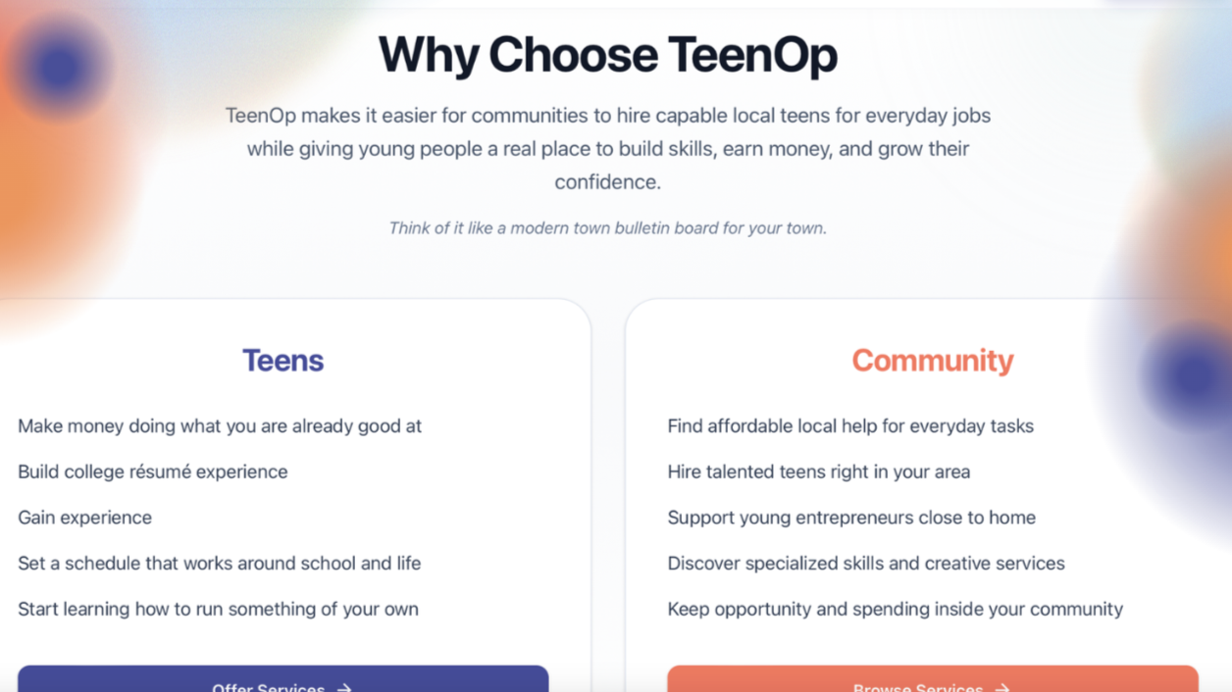

- Can you bullet the wording in the two boxes above. Also sorry I'm changing the wording one more time:
Teens:
- Start a small business in under 10 minutes
- Make money using existing skills/talents
- Choose when you work
- Gain experience
- Build College Resume
Community:
- Find affordable help for everyday tasks
- Hire talented teens in your community
- Support students at your local high schools
- Discover unique and creative services
- Keep opportunity in your community

- Can you take away “Built from a lunch table idea” and change it to “The TeenOp Story”

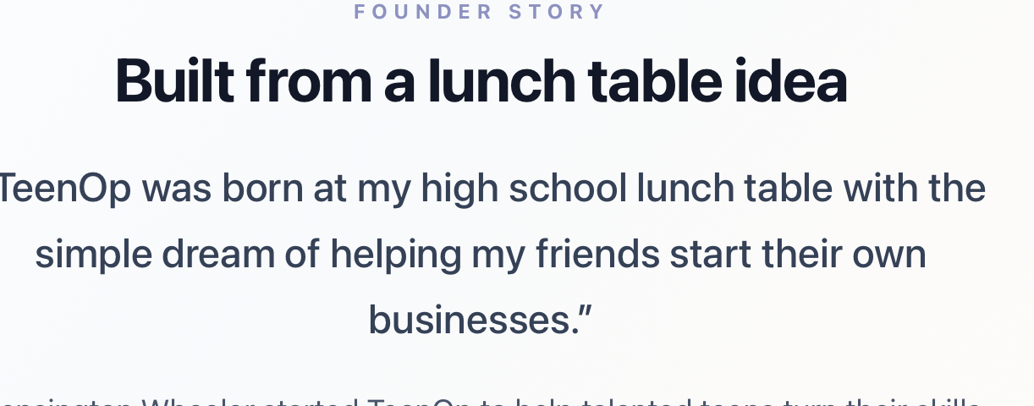

- I was wondering if it is possible to put in a thin rectangle in between the hero and the Why Choose TeenOp that has our other mission statement something like this(this one isn't as important but just thought I would throw it out there (I know you can make it look a lot better then I just did):

